Creating the Validation Method

Having created your test plan you need to create code that ensures your application passes your test cases. The code will require several If statements contained within a suitable function. The logic we shall use is as follows...

1. Declare a string variable to store the error message (if any)
2. Initialise the variable with a blank string
3. Test a unit of data to see if it is OK
If it isn’t OK concatenate an error into the string variable
If it is OK then go on to the next test
4. Perform all other tests using the same logic as 3
5. Once all tests are completed return the value of the string variable as the return value of the error message

The validation function will be created as a method in the class clsAddressPage. This will produce a method.

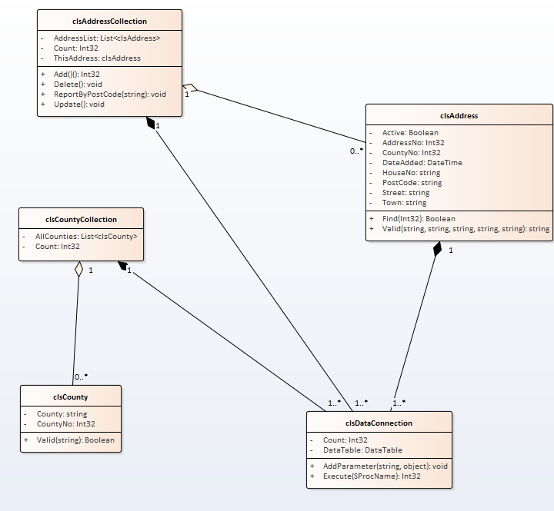

Creating the Function

The first step is to create the stub for the function so that we have a place to put the validation code. Inside your class definition for clsAddress create the following public function...

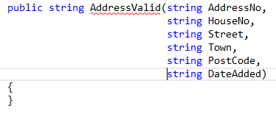

Things to note...

- We have split the function definition over several lines. We don’t need to use this trick but it does help to make it easier to read.

- We have a parameter for each item we want to test. It is important to point out also that each parameter has a data type of string. The reason for this is that string will accept data of any data type. Since we are passing data to this function that is yet to be validated we cannot make any assumptions about it being correct or not. For example DateAdded should be a date, however if the user enters an invalid date we cannot pass the data to the function if we make this parameter DateTime data type.

- The return data type of the function is string as it will contain the text of any error message.

In this case the function will return either a blank string if all is OK with the data or the error message if there is a problem.

- Lastly notice that the name of the function is underlined in red.

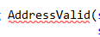

- This is because we haven’t set up the function to return a value yet, we shall do that now.

Setting up the Return Value of the Function

As we have mentioned several times already a function returns a value. To set this up we need to complete the following steps...

1. Declare a string variable to store the error message (if any)
2. Initialise the variable with a blank string
5. Once all tests are completed return the value of the string variable as the return value of the error message

Firstly declare a variable to store any error message...

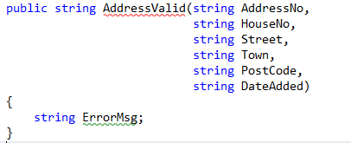

Next initialise the variable with a blank string...

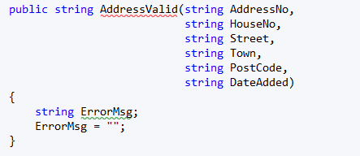

Lastly return the value of the ErrorMsg variable...

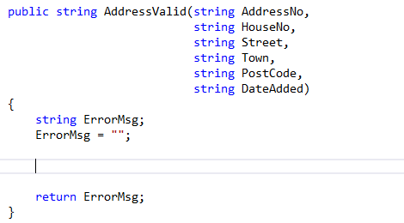

Notice we have created a few blank lines so that we have a place to create our If statements.

The next step is to create the first of probably many If statements.

The first value we shall check is the house number.

Last week we made a start on the test plan for this data which looked something like this...

Description of Item to Be Tested:

This field stores the house number of the address. This may be a number or it could contain a letter e.g. 33B so the data type is string. The field must be no more than six characters and may not be blank.
Test Type | Test Data |  | Expected Result | Actual Result
Extreme Min | Not applicable |  | NA
Min -1 | Blank |  | Display an error message stating required field.
Min (Boundary) | 1 character
Min +1 | 2 characters |  | Should accept the data
Max -1 | 12345 |  | Should accept the data
Max (Boundary) | 123456 |  | Should accept the data
Max +1 | 1234567 |  | Should display an error message
Mid | 123 |  | Should be ok
Extreme Max | 12345678901234567891234567890123456789  12345678901234567891234567890123456789  Etc.. |  | Should fail
Invalid data type | NA
Other tests | NA

The important items to note in the case of this data are the boundaries of the data. In this case the value must have at least one character and may not be more than six characters.

To test this we would use the built in string method Length.

Length

Length inspects the data passed as a parameter and counts the number of characters. The return value of the method is the number of characters in the string.

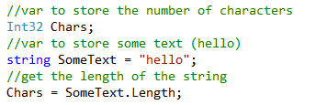

In the above example the variable Chars would be assigned the value 5.

The If statement could be constructed in a number of ways, we shall opt for the following structure...

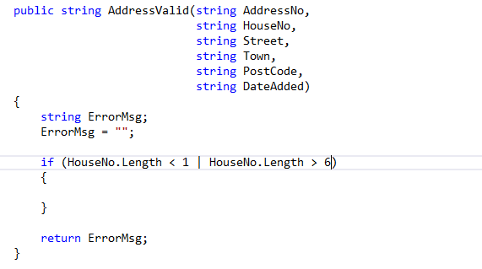

The logic for some of the If statements can be quite fiddly especially when you are getting started on this kind of thing. Expect to get this wrong while you are learning.

The logic above states if the house no has less than < one character OR more than > five characters generate an error.

The OR operator in C# is the | symbol.

The next step is to generate the error using concatenation...

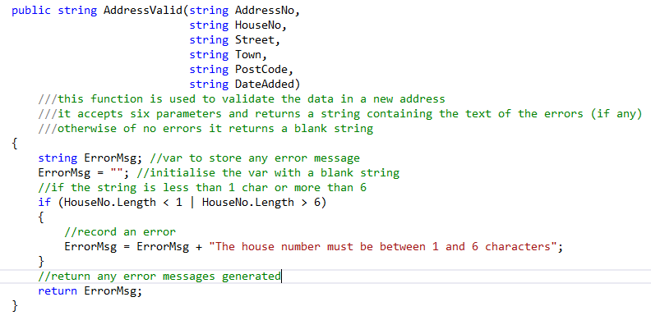

(We have also added a few comments for good measure.)

What would be a really good idea at this stage is to test the function to see if it works as we think it should.

Testing the Function

To test the function we need to modify the event handler for the OK button on the data entry form AnAddress.aspx.

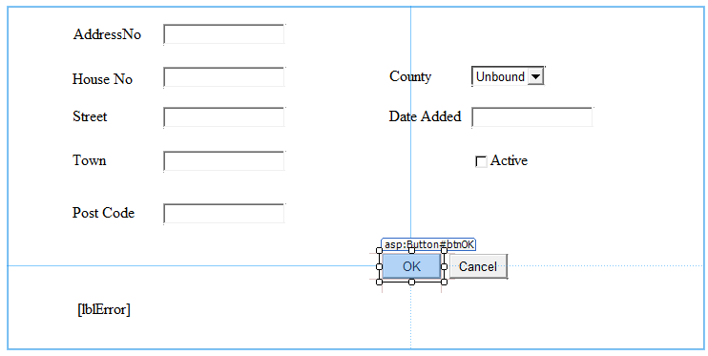

Go to design view and double click on the OK button to access the event handler like so...

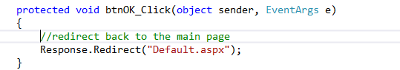

To test the validation function we will use the following code...

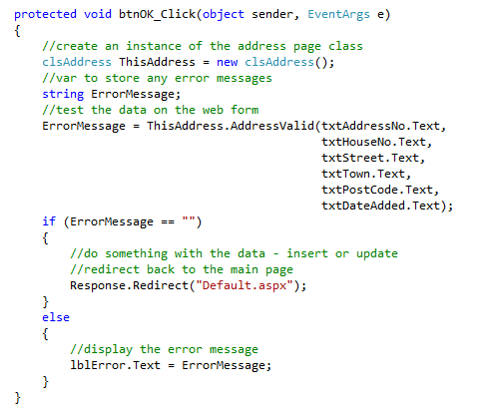

To test this place a break point in the function (F9) and then run the page. Enter some dummy data and see (using F10) if the validation works or not.

Now that we have a mechanism for checking if the logic for the validation is ok we may now go on and validate the rest of the data entered.

Here is a bit more code to get you started...

//var to store the error message
string ErrMsg = "";
//check the min length of the house no
if (HouseNo.Length == 0)
{
//set the error messsage
ErrMsg = ErrMsg + "House no is blank. ";
}
//check the max length of the house no
if (HouseNo.Length > 6)
{
//set the error messsage
ErrMsg = ErrMsg + "House no must be less than 6 characters. ";
}
//check the min length of the street
if (Street.Length == 0)
{
//set the error messsage
ErrMsg = ErrMsg + "Street is blank. ";
}
//check the max length of the street
if (Street.Length > 50)
{
//set the error messsage
ErrMsg = ErrMsg + "Street must be less than 50 characters. ";
}
//check the min length for the town
if (Town.Length == 0)
{
//set the error messsage
ErrMsg = ErrMsg + "Town is blank. ";
}
//check the max length for the town
if (Town.Length > 50)
{
//set the error messsage
ErrMsg = ErrMsg + "Town must be less than 50 characters. ";
}
//check the min length for the post code
if (PostCode.Length == 0)
{
//set the error messsage
ErrMsg = ErrMsg + "Post Code is blank. ";
}
//check the max length for the post code
if (PostCode.Length > 9)
{
//set the error messsage
ErrMsg = ErrMsg + "Post Code must be less than 9 characters. ";
}
//test if the date is valid
try//try the operation
{
//var to store the date
DateTime Temp;
//assign the date to the temporary var
Temp = Convert.ToDateTime(DateAdded);
}
catch//if it failed report an error
{
//set the error messsage
ErrMsg = ErrMsg + "Date added is not valid. ";
}
//if there were no errors
if (ErrMsg == "")
{
//return a blank string
return "";
}
else//otherwise
{
//return the errors string value
return "There were the following errors : " + ErrMsg;
}

Once you think that you have created a validation function that works you need to enter the test data from the test plan to see if you get the expected error messages.

